

**ESPD -Interoperability and Diffusion**

**Dx.0**

**Dissemination Report**

|  |  |
| --- | --- |
| **Project number** | INEA/CEF/ICT/A2016/1170516  2016-IT-IA-0038 |
| **Project acronym** | ESPD |
| **Project title** | ESPD – Interoperability and Diffusion |
| **Project duration** | 13 months (01/03/2017 – 31/03/2018) + 9 months |
| **Programme** | Connecting Europe Facility (CEF) |
|  |  |
| **Activity title** |  |
| **Deliverable number** |  |
| **Version (date)** | 0.0.1 |
| **Due date** |  |
|  |  |
| **Responsible organization** | Agid |
| **Editor** | Partners |
|  |  |
| **Abstract** |  |
| **Keywords** |  |

Deliverable Info

|  |  |
| --- | --- |
| **Responsible organization** |  |
| **Editor** |  |
| **Contributors** |  |
| **Reviewers** |  |
|  |  |
| **Abstract** | AGID |
| **Keywords** |  |
|  |  |
| **Acknowledgement** |  |
| **Disclaimer** | The sole responsibility of this publication lies with the author(s). The European Union is not responsible for any use that may be made of the information contained therein. |
| **Confidentiality** | The information in this document is confidential and restricted only to the members of the ESPD consortium  (including the Commission Services). |
|  |  |
| **Note** |  |
|  |  |

Page Intentionally Left Blank

**Change Log**

|  |  |  |  |  |
| --- | --- | --- | --- | --- |
| **Version** | **Date** | **Author** | **Organization** | **Description** |
| 0.0.1 | 11/10/2018 |  | FUB |  |
|  |  |  |  |  |
|  |  |  |  |  |
|  |  |  |  |  |
|  |  |  |  |  |

# Table of contents

Deliverable Info 1

Table of contents 4

Executive Summary 5

1. Introduction 7

1.1. Background of ESPD project 7

1.2. Specific objectives of this deliverable 7

2. Final Dissemination Report 9

2.1. Introduction 9

2.2. Objectives 9

2.3. Target groups for dissemination 10

2.4. Dissemination channels 11

2.4.1. Partners websites 11

2.4.2. Github 13

2.5. ESPD Scientific publications   13

2.6. ESPD Externally-organised events   14

2.7. ESPD Events organized by Consortium Partners   15

2.8. Project web presence 16

2.9. Project deliverables 16

2.10. Scientific exchange 17

2.1. ESPD Advisory Board 18

3. Final Exploitation Report 19

3.1. Individual partner exploitation activities 19

3.1.1. AGID (Agenzia per l’Italia Digitale) 19

3.1.2. A.N.AC. (Autorità Nazionale Anticorruzione) 19

3.1.3. Consip SpA 19

3.1.4. Intercenter (Intercent-ER Agenzia regionale per lo sviluppo dei mercati telematici) 19

3.1.5. UNIONCAMERE 19

3.1.6. MIT (Ministero delle infrastrutture e dei trasporti) 19

4. Final Communication Report 20

4.1. ESPD Communication Materials 20

5. Evaluation against Dissemination and Exploitation Plans 21

6. Conclusions and Future Actions 21

6.1. Summary Discussions 21

6.2. Post-Project Dissemination and Exploitation Activities 21

Abbreviations and Acronyms 22

Annex A Exploitation & Dissemination Reporting Template for Partners 23

Annex B Template for Workshop Evaluation 24

<Name of the Workshop> Evaluation Form 25

<Name of the Workshop> Questionario di valutazione 27

Executive Summary

To be completed.

This Page Intentionally Left Blank

1. Introduction
   1. Background of ESPD project
   2. Specific objectives of this deliverable

The objective of this deliverable is to present an overall communication and dissemination strategy designed to provide a comprehensive framework for the diffusion of ESPD aims and results, as well as to report the how these strategies have been pursued and the gained results. It provides a clear understanding of the target groups and actions needed to approach them. Furthermore, it explains the disseminations activities and tools and how they need to be employed during ESPD life so that the project and it results will be disseminated as widely and effectively as possible.

The dissemination strategy is being constantly updated based on the project development stage. These needs emerged through the close interaction with the target groups as well as among the ESPD consortium (the Consortium) partners themselves and their interaction with the main stakeholders. This deliverable aims to assist the Consortium to generate an effective flow of information and publicity about the objectives and results of work.

This activity necessarily starts with a “dissemination and communication plan” and, according to the Description of Work (DoW) as from the Grant Agreement (Annex 1 – Activities), is focused on elaborating and maintaining the dissemination plan during the whole project life. It will organize the ESPD specific dissemination events. It also organizes the participation of ESPD in wider dissemination events, symposiums and seminars and it must warrant that the relevant material is available and focused for each event.

Specifically, ESPD will:

* organise public outreach workshops in order to communicate ESPD’s objectives, scopes and results and receive feedback from stakeholders;
* engage directly with Public Administration, Enterprise and SME, Standardisation bodies, Contracting Authorities and Economic Operators;
* organize awareness events and exploit existing platforms, solutions and standards to create an engaged ESPD community as well as organize actions and produce training material (guides, scenarios of use, case studies) for institutional leaders and innovative organizations, as one of the main axes of exploitation, encouraging participants to introduce innovative aspects of the ESPD project.

The outcome of this task will be material and actions for target stakeholders, in order to disseminate the objectives, methodologies and achievements of the Project to all involved players in the market ecosystem.

The rest of deliverable is organized as follows.

* Section 2 outlines the final dissemination report. This includes a detailed review of dissemination activities across the different dissemination channels of the project.
* Section 3 presents the final exploitation report, including a listing of the exploitable assets from the project and an overview of exploration activities per partner.
* Section 4 presents the final communication report, including a listing of the communication material produced.
* Then Section 5 evaluates the dissemination and exploitation activities against previously defined roadmaps and KPIs.
* Finally, conclusions and future directions are discussed in Section 5

1. Final Dissemination Report
   1. Introduction

Dissemination is concerned of making ESPD project visible, creating awareness, understanding and promoting participation in the Project, assuring an effective impact on society, by carefully planning and implementing dissemination, exploitation, standardisation.

Therefore, a dissemination strategy needs to address the following issues:

* the aim of dissemination, Objectives;
* what will be disseminated, Project results;
* who is the audience, Target groups;
* what medium will be used, Resources;
* when will be disseminated, Timing.

Thereby, these issues cannot be regarded in an isolated way. The development of the dissemination activities is in line with ESPD progress status. Effective dissemination thus has to take into account the following principles:

* information has to be available, accessible, adaptable and diversified. Depending on the different purposes, target groups and cultural backgrounds, dissemination activities and tools need to be updated;
* information has to be relevant and compatible for the different user groups so as to reach its maximum understanding and impact;
* interaction with end-users has to be stressed. Analysing the end-users needs and responses creates links between the project goals and actual achievements. This interaction requires a constant adoption of dissemination activities.

All promotional material of ESPD will include its logotype, the CEF and EU Flag Logo.

* 1. Objectives

The dissemination plan aims to:

* develop a communication strategy through a concrete set of activities;
* offer to ESPD related stakeholders (Developers, Industry, Administrations, etc.) the maximum visibility of the Project;
* effective transfer of ESPD knowledge to prospective end users;
* inform the information management community (administration, industry, etc.) about ESPD;
* bring project achievements to the attention of as many relevant people as possible;
* aim to demonstrate the ways in which standard and innovation is contributing to a European 'Innovation Union' and account for public spending by providing tangible proof that collaborative activity adds value by:
* showing how European collaboration has achieved more than would have otherwise been possible, notably in achieving common standards, contributing to competitiveness and solving societal challenges;
* showing how the outcomes are relevant to our everyday lives, by creating jobs, introducing novel technologies, or making our lives more comfortable in other ways;
* making better use of the results, by making sure they are taken up by decision-makers to influence policy-making and by industry and the scientific community to ensure follow-up.

ESPD dissemination actions intend to maximize impacts related to awareness creation about the Project and its specific area of work, promotion of results to the different target groups and maximize potential exploitation of such results.

* 1. Target groups for dissemination

The target group concerns those who will be positively influenced by ESPD’s activities and outcomes. The consortium will ensure that the elaborated dissemination materials are appropriately adapted to the target audiences so that all activities can be tailored to the target groups’ special information need. The materials will be internally reviewed by the ESPD Consortium before exposition to the general audiences.

In order to aid the subsequent dissemination and tailor the information and approach for ESPD different audience types have been identified. For each audience, we should work on a distinct strategy using targeted messages, means and language. The main target areas will be the following.

1. The **EU community**: To be completed
2. The **Public authorities**: To be completed
3. The **Public Sector** and **Public Administration**: To be completed
4. The **Enterprises** and **SME**: To be completed
5. The **Standard bodies**: To be completed
6. The **Contracting Authorities** (CA) To be completed.
7. **Economic Operators** (OEs) To be completed.

* 1. Dissemination channels

Each Partner promoted the activities of project ESPD with a specificic page on their website containing a brief summary of the ongoing activities.

* + 1. Partners websites

Partner: AGID

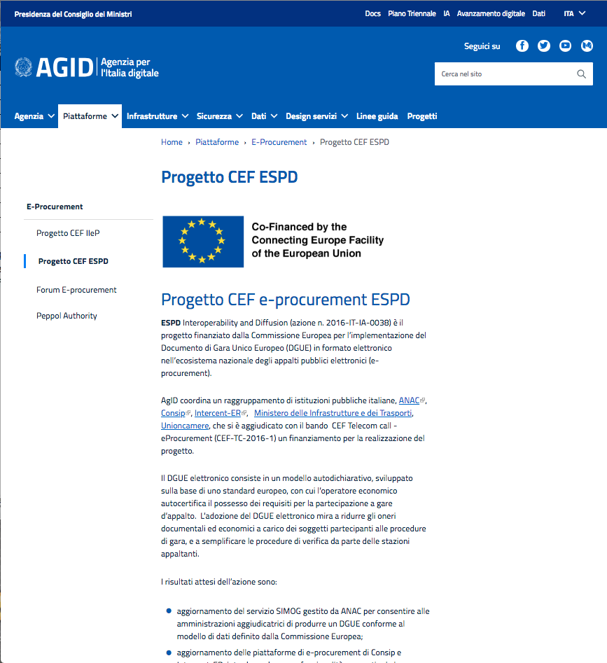

Figura 1: ESPD webpage on AGID portal

Source: <https://www.agid.gov.it/it/piattaforme/procurement/progetto-cef-espd>

Partner: INTERCENT-ER

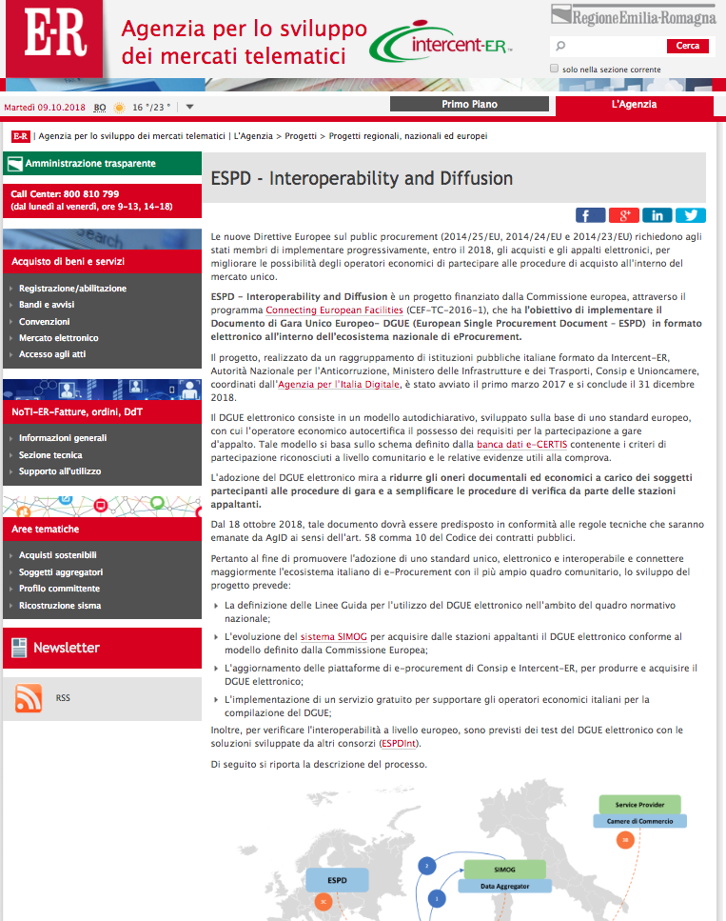

Source: <https://intercenter.regione.emilia-romagna.it/agenzia/progetti/progetti-regionali-nazionali-ed-europei-1/espd-interoperability-and-diffusion>

Partner: UNIONCAMERE

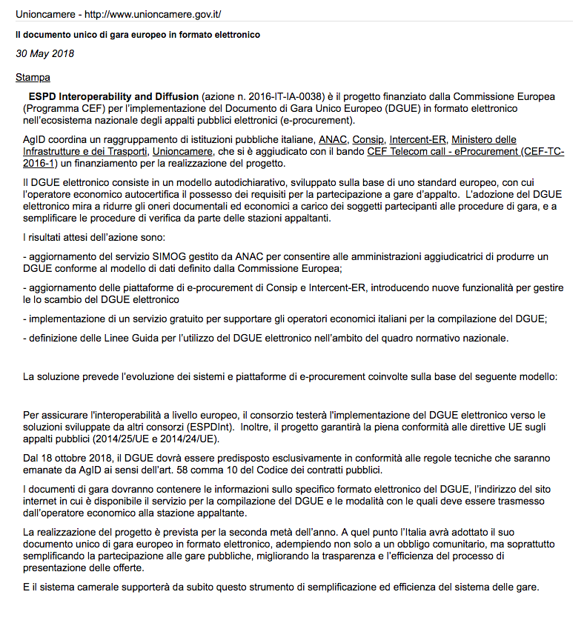

Source: <http://www.unioncamere.gov.it/stampa/il-documento-unico-di-gara-europeo-in-formato-elettronico_3770.htm>

Partner: CONSIP (NON PRESENTE)

Source: https://www.google.it/search?q=site%3Awww.consip.it+espd

Partner: ANAC(NON PRESENTE)

Source: https://www.google.it/search?q=site%3Awww.http%3A%2F%2Fwww.anticorruzione.it+espd

* + 1. Github

Documenti in pubblica consultazione

* 1. ESPD Scientific publications
  2. ESPD Externally-organised events

|  |  |  |  |  |  |  |  |  |
| --- | --- | --- | --- | --- | --- | --- | --- | --- |
| **Date** | **Place** | **Event** | **Title** | **Partners** | **Person** | **Available** | **Att.#** | **Target** |
|  |  |  |  |  |  |  |  |  |
|  |  |  |  |  |  |  |  |  |
|  |  |  |  |  |  |  |  |  |
|  |  |  |  |  |  |  |  |  |
|  |  |  |  |  |  |  |  |  |
|  |  |  |  |  |  |  |  |  |
|  |  |  |  |  |  |  |  |  |
|  |  |  |  |  |  |  |  |  |
|  |  |  |  |  |  |  |  |  |
|  |  |  |  |  |  |  |  |  |
|  |  |  |  |  |  |  |  |  |

Table 1 – Summary of ESPD presentations at external organised dissemination events

* 1. ESPD Events organized by Consortium Partners

|  |  |  |  |  |  |  |  |  |
| --- | --- | --- | --- | --- | --- | --- | --- | --- |
| **Date** | **Place** | **Event** | **Title** | **Partners** | **Person** | **Available material** | **Att.#** | **Target** |
|  |  |  |  |  |  |  |  |  |
|  |  |  |  |  |  |  |  |  |
|  |  |  |  |  |  |  |  |  |
|  |  |  |  |  |  |  |  |  |
|  |  |  |  |  |  |  |  |  |
|  |  |  |  |  |  |  |  |  |
|  |  |  |  |  |  |  |  |  |

* Table 2 – Summary of ESPD presentations at external organised organised by the ESPD consortium.
  1. Project web presence

|  |  |  |
| --- | --- | --- |
| **Partner** | **Type** | **Link** |
|  |  |  |
|  |  |  |
|  |  |  |
|  |  |  |
|  |  |  |
|  |  |  |
|  |  |  |
|  |  |  |
|  |  |  |
|  |  |  |
|  |  |  |
|  |  |  |
|  |  |  |
|  |  |  |
|  |  |  |
|  |  |  |
|  |  |  |
|  |  |  |
|  |  |  |
|  |  |  |
|  |  |  |
|  |  |  |
|  |  |  |

Table 3 – Summary of ESPD scientific exchange with other EC-funded Projects

* 1. Project deliverables

The following table shows all project deliverables denoting the lead participant, the type of report and the level of confidentiality.

|  |  |  |  |  |
| --- | --- | --- | --- | --- |
| Deliverable # | Title | Lead participant | Type | Dissemination level |
|  |  |  |  |  |
|  |  |  |  |  |
|  |  |  |  |  |
|  |  |  |  |  |
|  |  |  |  |  |
|  |  |  |  |  |
|  |  |  |  |  |
|  |  |  |  |  |
|  |  |  |  |  |
|  |  |  |  |  |
|  |  |  |  |  |
|  |  |  |  |  |

Table 4 – Project deliverables

* 1. Scientific exchange

Specificare progetti EC collegati ad ESPD

|  |  |
| --- | --- |
| **EC-funded Project** | **Synergies or links with ESPD** |
|  |  |
|  |  |
|  |  |
|  |  |
|  |  |
|  |  |

* Table 5 – Summary of ESPD scientific exchange with other EC-funded Projects.
  1. ESPD Advisory Board

The creation of an Advisory Board (AB) was a key strategy for the engagement of stakeholders from both industry communities. The ESPD AB consisted of the following members:

* # AGID
* # ANAC
* # INTERCENTER
* # UNIONCAMERE
* # CONSIP
* #MIT

1. Final Exploitation Report

|  |  |  |  |  |
| --- | --- | --- | --- | --- |
| **#** | **Exploitable Asset** | **Type** | **Owner/ / Partner Involved** | **Brief Description** |
|  |  |  |  |  |
|  |  |  |  |  |
|  |  |  |  |  |
|  |  |  |  |  |
|  |  |  |  |  |
|  |  |  |  |  |
|  |  |  |  |  |
|  |  |  |  |  |
|  |  |  |  |  |
|  |  |  |  |  |

Table 6 – List of exploitable assets.

* 1. Individual partner exploitation activities
     1. **AGID** (Agenzia per l’Italia Digitale)
     2. **A.N.AC**. (Autorità Nazionale Anticorruzione)
     3. **Consip** SpA
     4. **Intercenter** (Intercent-ER Agenzia regionale per lo sviluppo dei mercati telematici)

SATER e-procurement platform has been upgraded implementing all the features planned by the grant agreement.

To describe this upgrade, various actions have been planned and are underway, which mainly involved the Agency's institutional website at https://intercenter.regione.emilia-romagna.it/. In particular, the activities put in place concern the creation and putting online of a specific information section dedicated to the ESPD project, as well as the publication of a news item on the home page relating to the development of the project and the results achieved. Furthermore, the same information will be conveyed through the "Intercent-ER Magazine" newsletter of the month of December, which counts over a thousand subscribers, including Public Administrations of the territory and economic operators. Finally, a digital brochure was prepared and published containing detailed descriptive information on the ESPD project and its scope in the context of the Emilia-Romagna region. In addition Intercenter-ER has published a specific page on ESPD on their website (see link).

* + 1. **UNIONCAMERE**
    2. **MIT** (Ministero delle infrastrutture e dei trasporti)

1. Final Communication Report
   1. ESPD Communication Materials

The material and slides presented at the conferences was made available, whenever possible, in the respective sites at the end of the event.

|  |  |  |
| --- | --- | --- |
| **Partner** | **Type** | **Link** |
| **AGID** |  |  |

Table 7 – Communication material

* 1. Individual partner communication activities
     1. **Intercent-ER**

In relation to the communication and dissemination activities envisaged by the Intercent-ER Agency, the following actions have been activated and completed:

* publication on the institutional website of Intercent-ER of an information section with a detailed description of the ESPD project (see [link](https://intercenter.regione.emilia-romagna.it/progetti/progetti-regionali-nazionali-ed-europei-1/progetti-europei/espd));
* publication on the institutional website of Intercent-ER of a news on the results achieved in the context of ESPD and on the closure of the project (see [link](http://intercenter.regione.emilia-romagna.it/notizie/2018/dicembre/si-conclude-il-progetto-espd-2013-interoperability-and-diffusion));
* insertion of news on ESPD on the monthly Intercent-ER Magazine newsletter (see [link](http://intercenter.regione.emilia-romagna.it/newsletter/archivio-newsletter/2018/intercenter-magazine-n-12anno-XIII));
* creation of a digital brochure, to be published on the institutional website of Intercent-ER, containing descriptive information on the ESPD project and its application in the context of the Emilia-Romagna region (see [link](https://intercenter.regione.emilia-romagna.it/progetti/progetti-regionali-nazionali-ed-europei-1/progetti-europei/espd/LeafletESPD_def.pdf/@@download/file/Leaflet%20ESPD_def.pdf) for automatic download of the pdf document);

All the aforementioned activities have been completed with success in the last phase of the project and are in detail in the links above and in the following documents, included in the attached circle to the Deliverable.

In particular the leaflet is a comprehensive 19 pages document the ESPD project (see Figure 1).

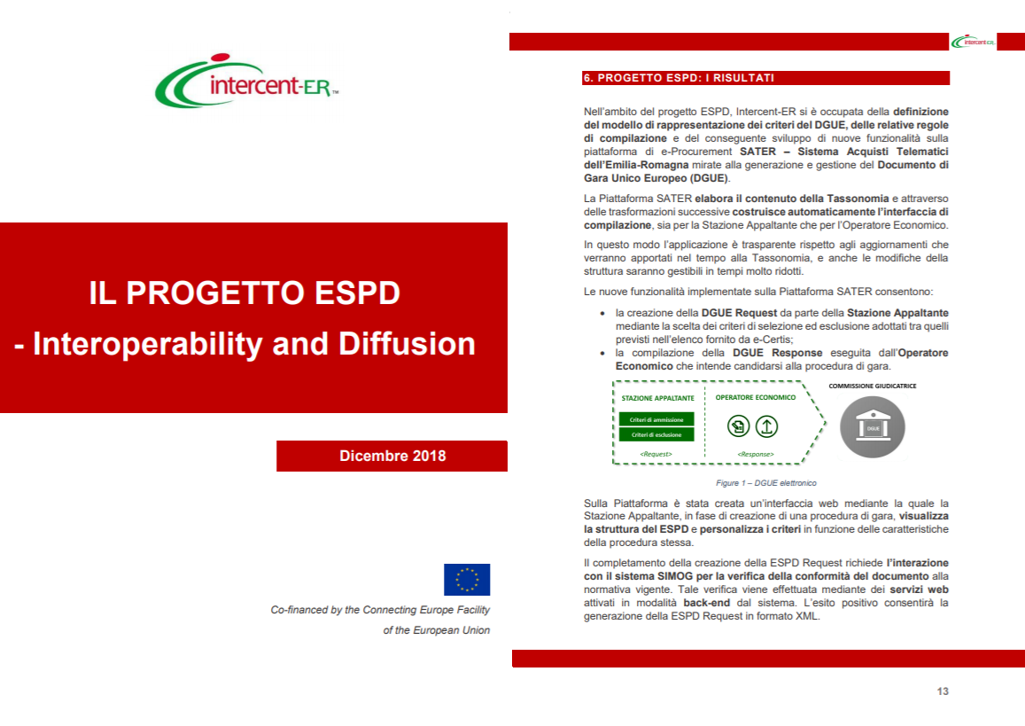

Figure 1 The leaflet produced by Intercent-ER on ESPD project  
(the frontispiece, and the page introducing ESPD results)

1. Evaluation against Dissemination and Exploitation Plans
2. Conclusions and Future Actions
   1. Summary Discussions
   2. Post-Project Dissemination and Exploitation Activities

Abbreviations and Acronyms

|  |  |
| --- | --- |
| **Abb./Acr.** | **Meaning** |
| **CA** | Consortium Agreement |
| **CEF** | Connecting Europe Facility |
| **CEN** | European Committee for Standardization |
| **GA** | General Assembly or Grant Agreement |
| **ICT** | Information and Communication Technologies |
| **ISO** | International Organization for Standardization |
| **PA** | Pubblica Amministrazione (*i.e. Public Administration*) |
| **PC** | Project Coordinator |
| **PEPPOL** | Pan-European Public Procurement Online |
| **PL** | Partner Leader |
| **PMB** | Project Management Board |
| **PMH** | Project Management Handbook |
| **QAP** | Quality Assurance Plan |
| **QM** | Quality Manager |
| **TL** | Task Leader |
| **WP** | Work Package |
| **WPL** | Work Package Leader |

1. Exploitation & Dissemination Reporting Template for Partners

**Report Identifier**

•  <partner name or short name>

•  <contact person>

•  <reporting period>

**For all points, try to answer the following questions (if fitting)**

•  who? (e.g. was presenting?)

•  what? (e.g. was presented)

•  where? (if appropriate)

•  when?

•  why? (what was the purpose of the meeting? how does it relate to ESPD?)

•  outcomes? recommendations? research directions?

**Activities  Dissemination**

•  Scientific

•  Other External Publications <please list, preferable in IEEE format or comparable>

•  Internal Publications / White papers / Technical reports

•  Scientific presentations (external or internal) <please list>

•  Press releases (and similar dissemination activities) <please list>

•  Dissemination to end-users (e.g. via dedicated institutions or associations) <please list>

•  Participation at or hosting of (scientific/expert) workshops <please list>

**Exploitation**

•  Presentation / poster at industry fora or events (including standardisation bodies) with primarily non-scientific audience

•  Dissemination at interested industry partners <please list>

•  Exploitation in the startup scene

•  Products created or adapted, or product developments influenced <please list>

•  Integration in lecturing / teaching

•  Personnel training, in-house training

•  Contribution to standards or guidelines for the domain / Exchange with bodies involved in

corresponding activities

•  Open-Sourcing of code <please list, describe, license, link>

1. Template for Workshop Evaluation

**Instructions to the Organizers**

It is a good idea to evaluate the logistics and organization of the event where the modules are presented as well as evaluate the participants' perception of the workshop: did they like it? was the material presented relevant to their work? This type of feed back will provide the organizers with information for the improvement of future events.

<Name of the Workshop> Evaluation Form

1) What is your overall assessment of the event? (1 = insufficient - 5 = excellent)

1 2 3 4 5

2) Which topics or aspects of the workshop did you find most interesting or useful?

|  |  |
| --- | --- |
|  |  |
|  |  |
|  |  |
|  |  |

3) Did the workshop achieve the programme objectives?

Yes No

If no, why?

4) Knowledge and information gained from participation at this event?

Met your expectations Yes No Somehow

Will be useful/applicable in my work Definitely Mostly Somehow Not at all

5) How do you think the workshop could have been made more effective?

6) Please comment on the organization of the event (from 1 = insufficient to 5= excellent)

1 2 3 4 5

7) Comments and suggestions (including activities or initiatives you think would be useful, for the future)

Further comments or suggestions

**THANK YOU!**

<Name of the Workshop> Questionario di valutazione

1) Quale è il suo giudizio complessivo dell’evento ? (da 1 = insufficiente a 5 = eccellente)

1 2 3 4 5

2) Quali argomenti del workshop ha trovato maggiormente utili o interessanti?

|  |  |
| --- | --- |
|  |  |
|  |  |
|  |  |
|  |  |

3) Sono stati secondo lei raggiunti gli obiettivi del programma ?

Si No

Se no, perché?

4) Le conoscenze ed informazioni acquisite durante l’evento

Soddisfano le sue aspettative Si No In qualche modo

Saranno utili/applicabili nel suo lavoro Sicuramente Per lo più In qualche modo Per niente

5) Come pensa che il workshop sarebbe potuto essere più efficace ?

6) Come valuterebbe l’organizzazione dell’evento (da 1 = insufficiente a 5= eccellente)

1 2 3 4 5

7) Commenti e suggerimenti (includendo attività ed iniziative che pensa potrebbero essere utili in futuro)

Ulteriori commenti o suggerimenti

**La ringraziamo per la collaborazione!**